Ray J Keen
Memorial Day
It is proposed to hold a memorial match at
Chesham Bowling Club, Bury lane, Chesham, HP5 1HX
Sunday 21ST August 2022
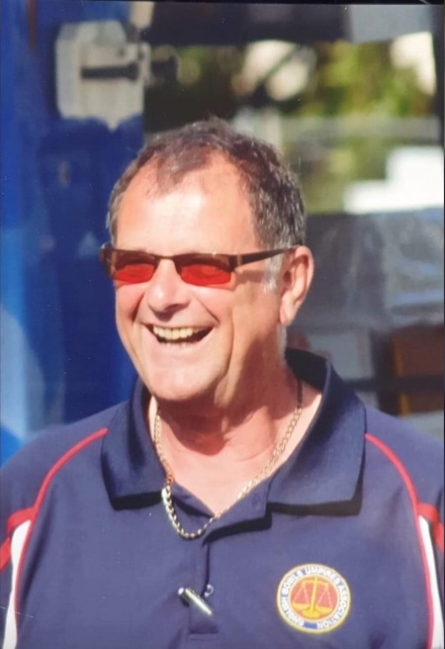
In aid of Florence Nightingale Hospice
A charity supported by Ray
We will play Rinks.
Club or Association Colours and Whites
Cost per person, £25
to include tea or coffee & a BBQ at the end of the game
Two sessions if numbers permit 10.30am & 2pm
There will be a raffle and prizes would be appreciated
The bar will be open from midday

Ray J Keen
Memorial Day
Team Entry
Please use a separate form for each team entered
Maximum 24 teams on the day, first come, first served.
We are expecting a high demand for this day so please apply early.
Contact Name……………………………………………………….
Club or Association……………………………………………….
Telephone No……………………………………………………….
Email address………………………………………………………..
Please choose AM or PM
Please state any dietary requirements or Allergies
……………………………………………………………………………………………………….
……………………………………………………………………………………………………….
Email to: cheshambowlingclub@gmail.com
Payments to Lloyds Bank Sort code 30-91-91
Acc No 00037071
Or by cheque to: Chesham Bowling Club
C/o John Holland (Hon Sec)
Hawthorn Cottage, New Road, Coleshill, BUCKS. HP7 0LE
Payments will be returned to anyone applying above the 24 limit. If demand requires, we will hold a second day, probably next year.
Download further entry forms from our website www.cheshambowlingclub.org.uk

