CHESHAM BOWLING CLUB
NEWSLETTER March 2021

Welcome to our third newsletter.

A mixed month of fortunes, earlier in the month we found we had been awarded another £2,500 grant which was just as well as we decided to do something about the sever damage to the green, mostly by crows searching for grubs. It was decided to NET the whole green which cost us £1,200, but seems to have done the trick as no further damage was created. It should also help with the rabbits of which Ray Morgan has spend some time reducing their numbers. It appears the duck’s like to use it as a tramopline!

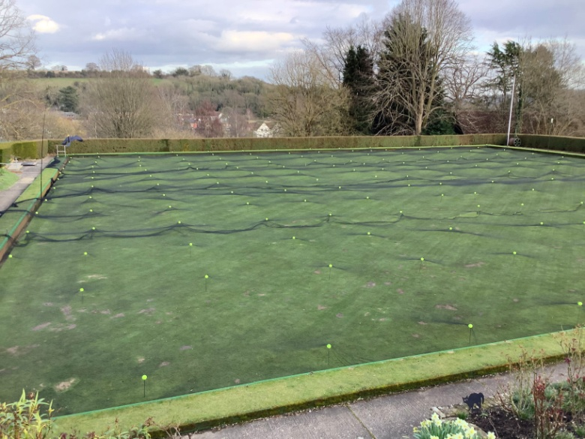

Ray’s funeral has taken place and we are holding a memorial/wake on the 30th July, so we will not be playing any games on that day or using the clubhouse, as we think the club will be packed with visitors which will include any of our own membership who wish to attend.

5 of us attended George Fudge’s funeral on Thursday and it was nice to see people at the roadside in respect for George. Although there were only a few of us it was very well done and George would have approved I am sure RIP.

A few more days to pay your subs and enter the comps.

We have applied to Bowls England for their Big Bowls Weekend literature and promotional material, so watch this space. It is planned to put a short mat in the town centre as a promotional exercise for new members, if it takes place we will need some volunteers on the 22 May, please help if you can.

We have a couple of important jobs to fill in the club. We need a cleaner for the forthcoming season and if you want to volunteer or know of someone, please get in touch. This is a paid post, wages by agreement.

The second is a Webmaster to upgrade our website, Howard and Tony look after it but it is felt new eyes would help.
We are still looking for volunteers for Green upkeep. If we can split the jobs between a group then “many hands make light work” in other words we don’t want anybody to do it all just small jobs say once a month or fortnight usually only taking an hour or so. Please get in touch.

To clarify. There is NO catering this year apart from a very few matches, all friendlies are tea and biscuits/cake so no cooking.

The news you have all been waiting for. The green is opening on the 21st April.
Only 3 rinks will be available owing to the bird damage. You must book a rink, Howard has found a suitable setup, and they will be available to book on line, or by phoning me 01494 729357. Sessions are 2pm-4pm, 4pm-6pm and 6pm-8pm. All equipment is in use and you can share mats and jacks. If you prefer your own please use them. You must sanitise your hands before using anything and sanitise when you have finished, there will be a book that you must sign in for test and trace, please ensure you do so. It is hoped that later in April we will be able to relax the rules further. The disabled toilet will be in use but you may have to unlock the clubhouse and remember to re-lock when you leave.

Finally, it’s time to start work again on the club patio. Geoff and I are going to the club on the 8th at 9 ish, so put on your overalls and boots and come and join us. If you have an electric screw diver please bring it as there are the tabletops to assemble, those, and the seats to bolt down onto the newly painted metalwork.

Keep well and safe.

Chesham Bowling Club

